Formal Troubleshooting Documentation Report
Lab Title: Practical Lab 02 — Part 1: Routing Troubleshooting Lab
Course / Module: Network Routing & Operations
Date: September 12, 2026
Status: Resolved (Full End-to-End Reachability Achieved)

1. Case Overview
Main Network Problem: The initial topology was partially configured with incorrect end-device settings, interface administrative shutdown states, and incomplete routing tables, resulting in broken end-to-end communication across local and remote LAN segments.
Affected Networks & Devices:
- PC-HQ Network: 192.168.10.0/24 (Gateway: 192.168.10.1)
- PC-IT Network: 192.168.20.0/24 (Gateway: 192.168.20.1)
- PC-Branch Network: 192.168.30.0/24 (Gateway: 192.168.30.1)
- WAN Links: 10.0.12.0/30 and 10.0.23.0/30 connecting Router0, Router1, and Router2.

Expected Final Result: Complete IP reachability across all site networks without rebuilding the topology or changing the IP addressing scheme. All four mandatory ICMP ping tests must succeed with a 0% packet loss rate.

2. Initial Symptoms
During the diagnostic phase, the following observations and failures were recorded prior to applying fixes:
Failed ICMP Ping Tests:
PC-HQ (192.168.10.10) $\rightarrow$ PC-Branch (192.168.30.10): Destination Host Unreachable / Request Timed Out.
PC-IT (192.168.20.10) $\rightarrow$ PC-Branch (192.168.30.10): Request Timed Out.
PC-Branch (192.168.30.10) $\rightarrow$ PC-HQ (192.168.10.10): Request Timed Out.
Initial Observations:
PC-HQ had an incorrect default gateway configured (192.168.10.254), preventing it from sending non-local subnet traffic to its router.
Router1 Interface Gig0/1 was in an administratively down state, breaking the WAN link between Router0 and Router1.
Router0 and Router2 lacked default paths to reach unknown remote networks.

3. Troubleshooting Steps

Issue A: PC-HQ Incorrect Default Gateway
Device Checked: PC-HQ
Command Used: ipconfig
Output / Observation: Default Gateway was set to 192.168.10.254.
Meaning: PC-HQ was trying to forward out-of-subnet packets to a non-existent gateway address instead of its local router interface.
Root Cause: Manual IP misconfiguration on host PC-HQ.

Issue B: Router1 WAN Interface Down
Device Checked: Router1
Command Used: show ip interface brief
Output / Observation: Interface GigabitEthernet0/1 showed Status: administratively down, Protocol: down.
Meaning: Physical/layer-2 connection between Router0 and Router1 was inactive.
Root Cause: Interface was left in its default shutdown state.

Issue C: Missing Routing Paths on Gateway Routers
Device Checked: Router0 & Router2
Command Used: show ip route
Output / Observation: Routing tables contained only directly connected networks (C) and lacked any static or dynamic default entries.
Meaning: Neither gateway router had a path to reach remote subnets.
Root Cause: Absence of a default route pointing toward the network core.

4. Fix Implementation

Fix 1: Correct Default Gateway on PC-HQ
Device: PC-HQ
Configuration: Changed Default Gateway from 192.168.10.254 to 192.168.10.1.
Why Needed: Allows PC-HQ to properly direct traffic destined for remote networks to Router0's Gig0/0 interface.
Why Correct: Matches the configured IP address on Router0's local LAN interface.

Fix 2: Enable WAN Interface on Router1
Plaintext
Router1# configure terminal
Router1(config)# interface GigabitEthernet0/1
Router1(config-if)# no shutdown
Router1(config-if)# exit
Router1# write memory
Why Needed: Re-establishes link status and allows IP traffic to flow over the 10.0.12.0/30 WAN link.
Why Correct: Brings the interface up administratively, changing status and protocol to up/up.

Fix 3: Configure Default Route on Router0
Plaintext
Router0# configure terminal
Router0(config)# ip route 0.0.0.0 0.0.0.0 10.0.12.2
Router0(config)# exit
Router0# write memory
Why Needed: Provides a catch-all gateway of last resort for any traffic leaving the HQ network.
Why Correct: Forwards all outbound traffic to the next-hop address 10.0.12.2 on Router1.

Fix 4: Configure Default Route on Router2
Plaintext
Router2# configure terminal
Router2(config)# ip route 0.0.0.0 0.0.0.0 10.0.12.1
Router2(config)# exit
Router2# write memory
Why Needed: Establishes return path connectivity for all traffic originating from or returning to the Branch network.
Why Correct: Directs all non-local packets toward the next-hop interface 10.0.12.1.

5. Verification Evidence
All required ICMP ping tests were executed from the Command Prompt windows on the respective end-devices, confirming 100% packet transmission success.

Test 1: PC-HQ to PC-IT (192.168.20.10)
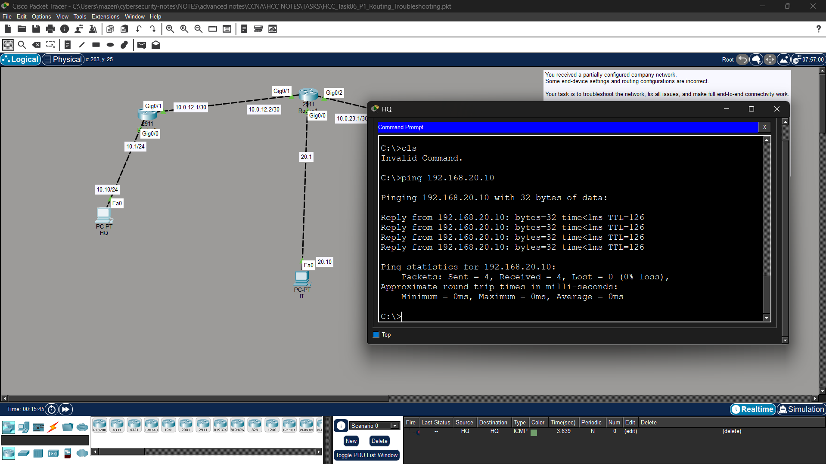

Test 2: PC-HQ to PC-Branch (192.168.30.10)

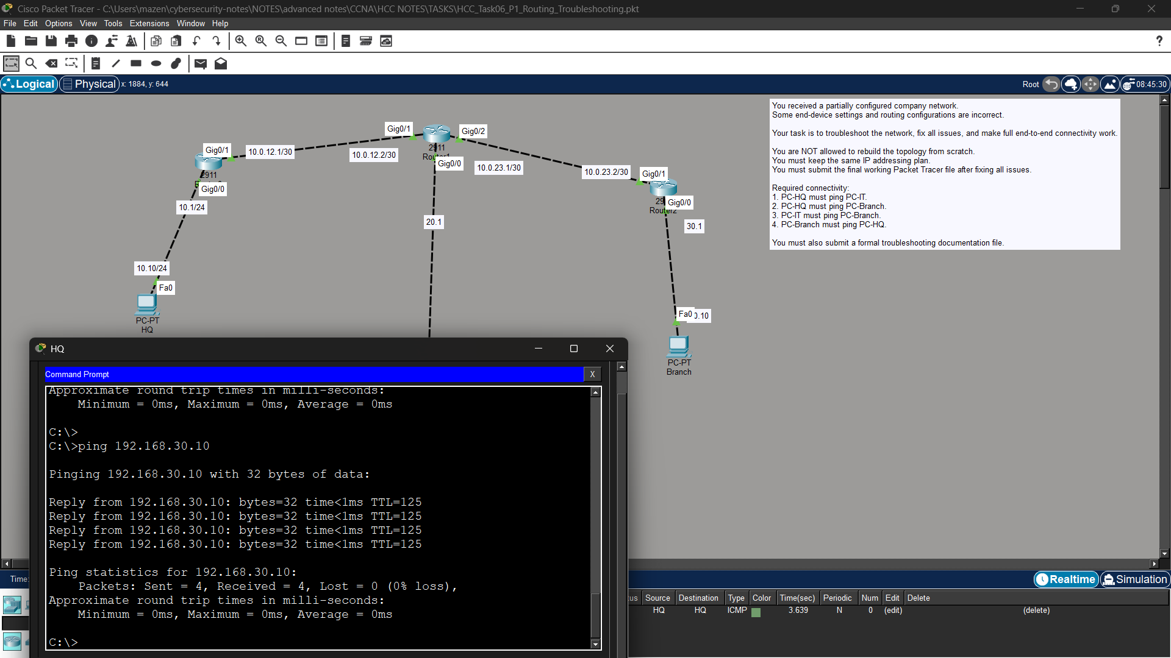

Test 3: PC-IT to PC-Branch (192.168.30.10)

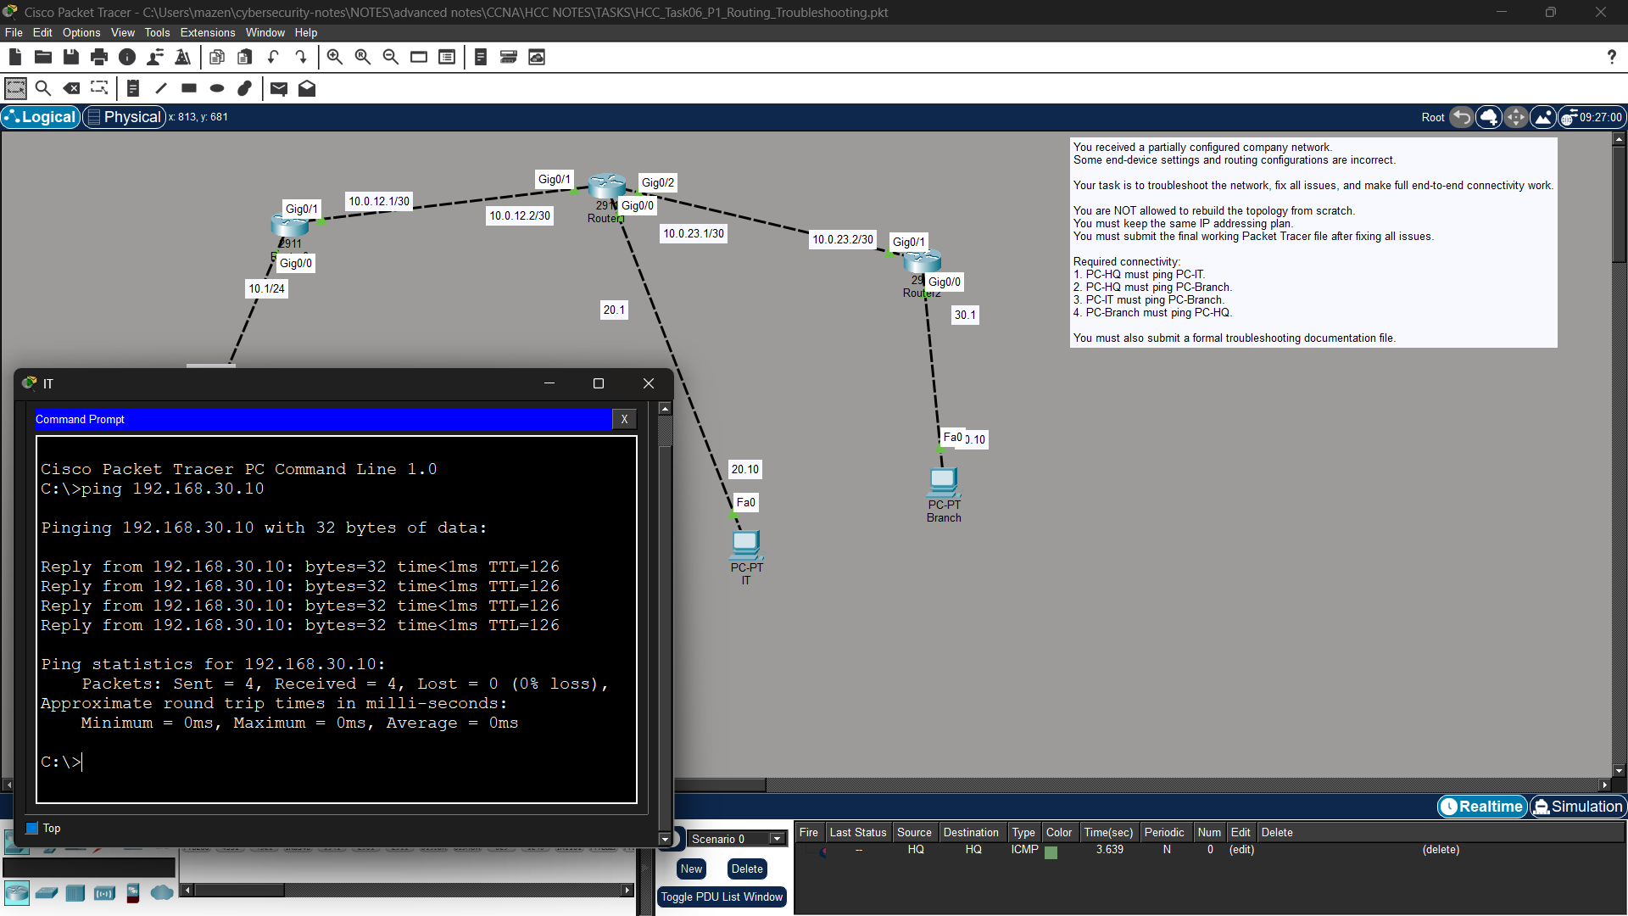

Test 4: PC-Branch to PC-HQ (192.168.10.10)

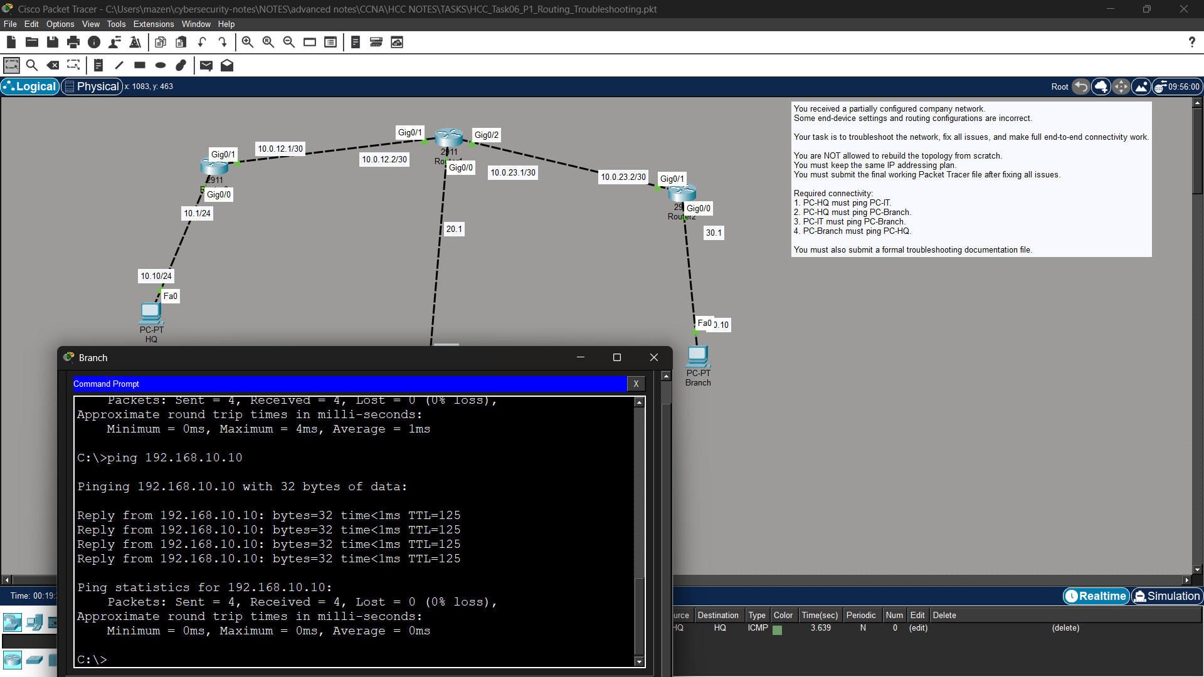

6. Final Summary
Summary of Fixes:
Updated PC-HQ default gateway settings from 192.168.10.254 to 192.168.10.1.
Enabled interface GigabitEthernet0/1 on Router1 using no shutdown.
Configured default static routes (0.0.0.0 0.0.0.0) on Router0 (via 10.0.12.2) and Router2 (via 10.0.12.1) to handle all external routing destinations cleanly.

Key Learnings:
Host-level misconfigurations (like wrong gateways) can block connectivity even if routing tables are completely correct.
Always verify physical and administrative interface states (show ip interface brief) before troubleshooting routing logic.
Default routing (0.0.0.0/0) provides a simple, effective solution for edge routers forwarding traffic toward a central hub.
First Action Item for Future Issues: Check interface administrative states (show ip interface brief) and host gateway assignments (ipconfig) first before inspecting dynamic or static routing configurations.

